Install and Configure Barman

Feature of Barman.
BARMAN (Backup and Recovery Manager) is an open-source administration tool for backup and disaster recovery of PostgreSQL servers. It allows performing remote backups of multiple servers.
Following are barman features.
1) Open Source Tool.
2) Remote backup and restore of multiple Servers.
3) Backup catalogs.
4) Incremental backup is possible.
5) You can define retention policies.
6) Archiving and compression of Wal files and backup files.
7) Support both rsync or postgresql protocols.



Step 1. Verify PostgreSQL repository:

# yum repolist
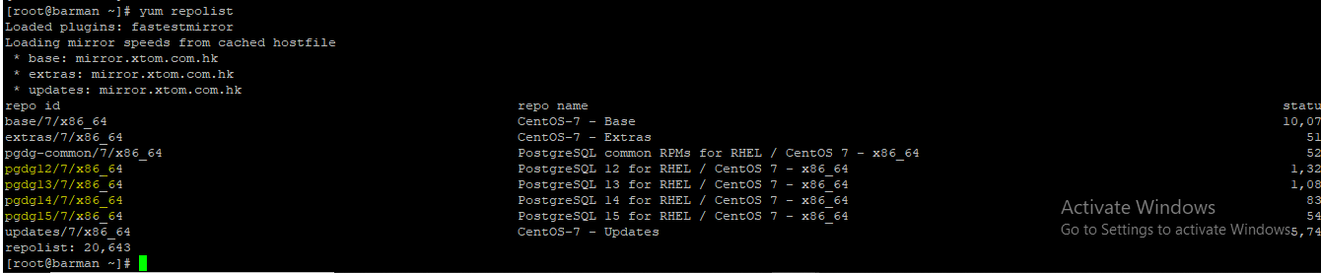

Note- If the repository not there install the repo from the below command:-
# sudo yum install -y https://download.postgresql.org/pub/repos/yum/reporpms/EL-7-x86_64/pgdg-redhat-repo-latest.noarch.rpm
Step 2. Install barman:
# yum install barman
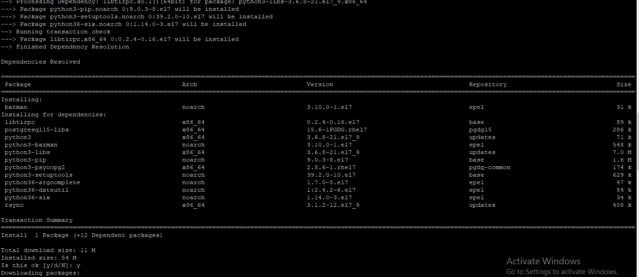

Note:- In case any Dependency error run below the command.
# yum install -y https://repo.ius.io/ius-release-el7.rpm

Step 3. Verify barman package installation
# id barman
# su – barman
$ barman --version
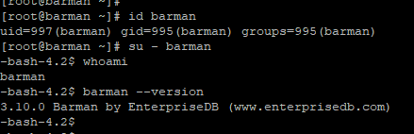

Step 4. Set Password for OS Account barman
# passwd barman
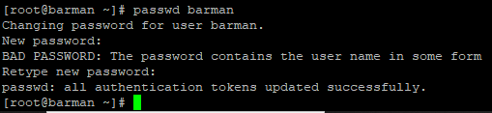

Step 5. Configure Passwordless Authentication in Barman Server:

# su – barman
$ ssh-keygen -t rsa
$ ssh-copy-id -i ~/.ssh/id_rsa.pub postgres@ 192.168.1.8
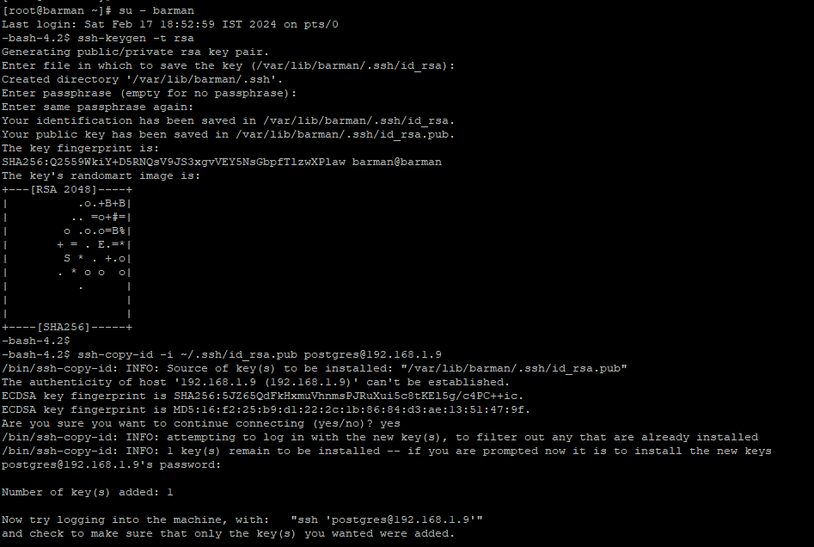

The same step follow in the Postgres machine as well we did in step 5

# su – postgres
$ ssh-keygen -t rsa
$ ssh-copy-id -i ~/.ssh/id_rsa.pub barman@192.168.1.10
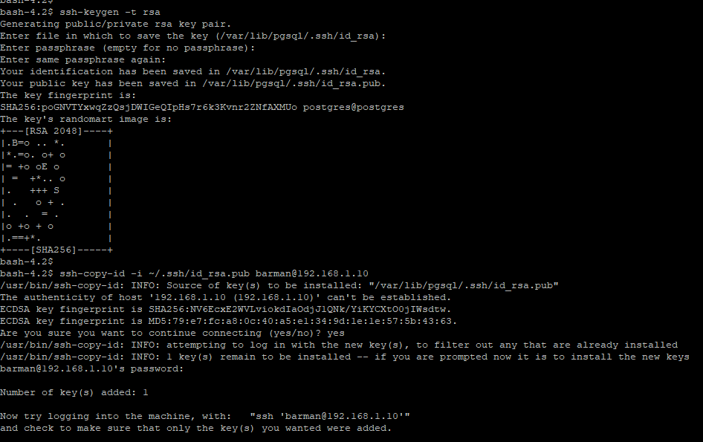

Step 5. Configure Global Configuration File in Barman Server
$ cd /etc/barman/
$ ls –lthr
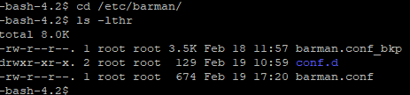

-bash-4.2$ cat barman.conf
[barman]
; System user
barman_user = barman
; Directory of configuration files. Place your sections in separate files with .conf extension
; For example place the 'main' server section in /etc/barman/conf.d/main.conf
configuration_files_directory = /etc/barman/conf.d
; Main directory
barman_home = /var/lib/barman
; Log location
log_file = /var/log/barman/barman.log
log_level = INFO
; Default compression level: possible values are None (default), bzip2, gzip, pigz, pygzip or pybzip2
compression = gzip
last_backup_maximum_age = 3 DAYS
; Retention policy (based on redundancy)
retention_policy = REDUNDANCY 2
;wal_retention_policy = main
path_prefix = /usr/pgsql-15/bin/

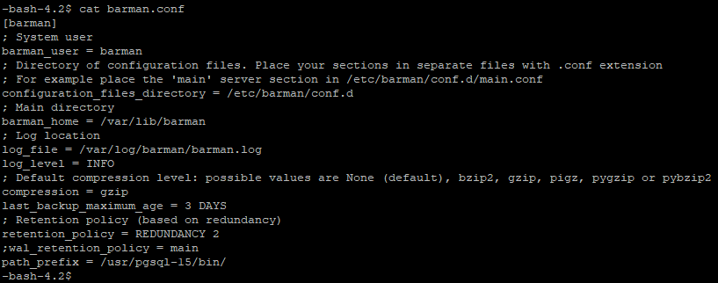

2nd Important file path is /etc/barman/conf.d
Cd /etc/barman/conf.d
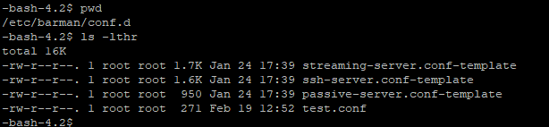

-bash-4.2$ cat test.conf
[test]
description = "Streaming PostgreSQL backup"
conninfo = host=192.168.1.8 user=postgres dbname=test password=postgres@123
streaming_conninfo = host=192.168.1.8 user=postgres password=postgres@123
backup_method = postgres
streaming_archiver = on
slot_name = barman
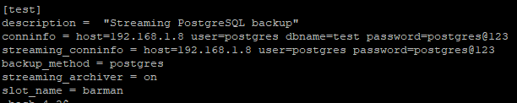

Step 6. Verify the server name

barman list-server
test - Streaming PostgreSQL backup
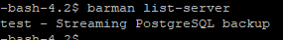

Step 7 set parameters in postgresql.conf file on Postgres DB
listen_addresses = '*'
wal_level=replica
max_wal_senders=10
max_replication_slots=10
archive_mode = on
archive_command = 'cp %p /var/lib/pgsql/15/archivedir/%f'
hot_standby = on

Set parameters in pg_hba.conf.conf file:
#ip4 host all all 0.0.0.0/0 md5
#replication privilege
host replication postgres 192.168.1.8 md5

Step 8. Force Switch WAL in Barman Server
su – barman
barman switch-xlog --force --archive test

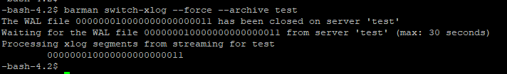

Run barman check test-machine02 again to verify settings. Now it should be all OK.
$ barman check test
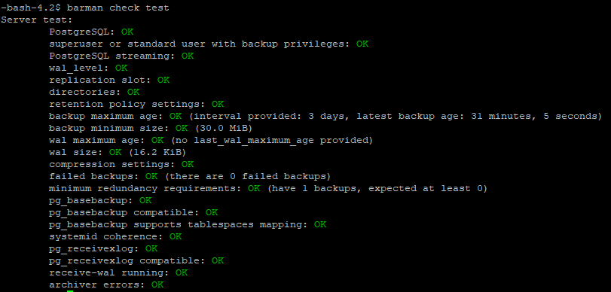

Some important commands

barman receive-wal --create-slot test
barman switch-xlog --force --archive test
barman receive-wal test --reset
barman show-server test | grep incoming_wals_directory
barman receive-wal
barman cron
barman replication-status test
barman delete test 20240220T112834

Backup and Restoration
$ barman backup test
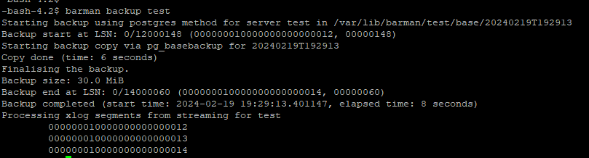

Check backup
$ barman list-backup test
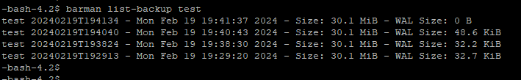

Backup restore
Take latest backup.
$ barman backup test

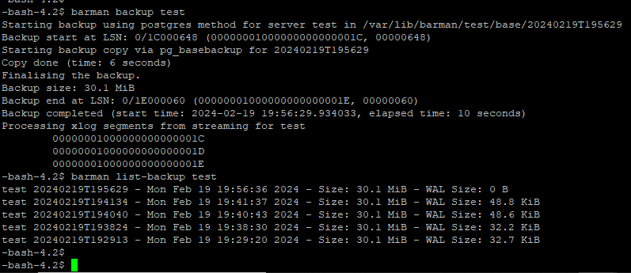
Check table data on Primary DB.
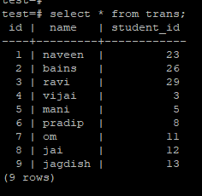
Stop Primary DB
# systemctl stop postgresql-15
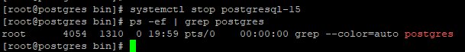

Remove all directories and files under the data directory
# cd /postgres_15/data/
# ls -lthr
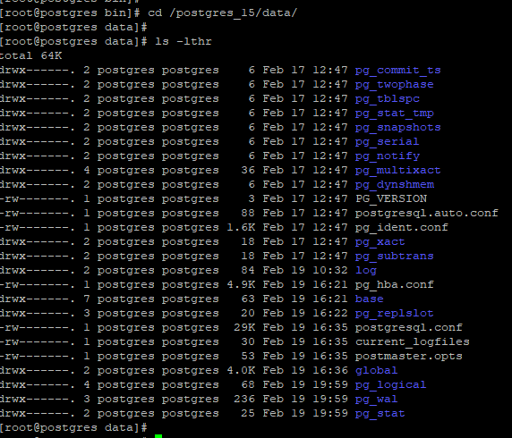

# rm -rf *
# ls –lthr
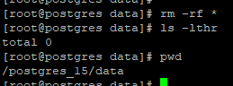

Run restoration command on Barman Server.
barman recover --remote-ssh-command "ssh postgres@192.168.1.8" test 20240219T195629 /postgres_15/data/

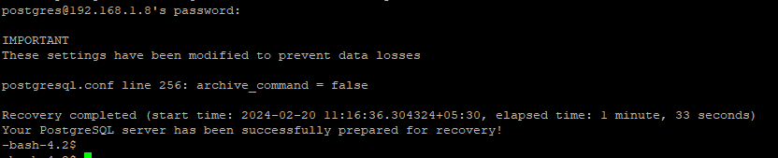
Check Primary Server
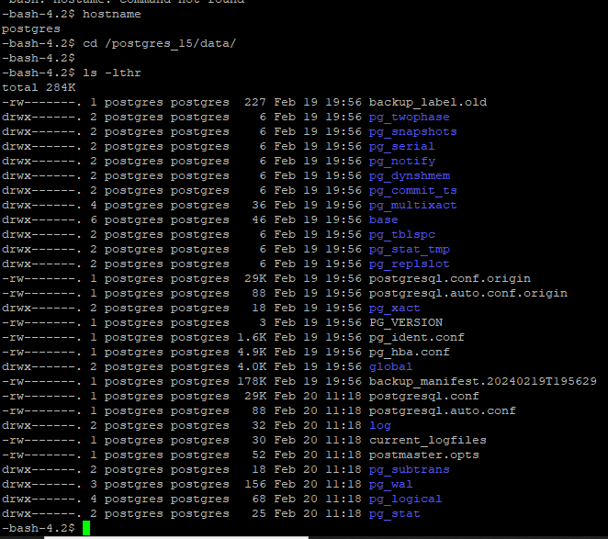

Now start DB
# systemctl start postgresql-15
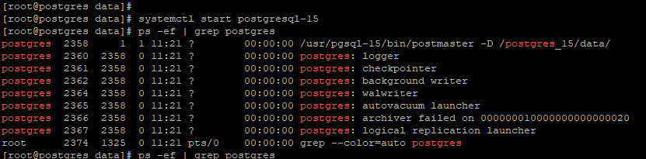

Login DB and check data
# psql -U postgres
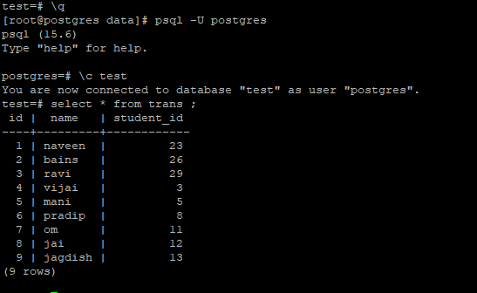

Schedule backup in cron job.

bash-4.4$ crontab -u barman -l
#================================
# BARMAN CRON JOB
# DATE: 06 MAY 2022
#================================

#BARMAN CRON: KEEP BARMAN SERVER RECEIVING LATER WAL FILES
/1 * barman cron > /home/barman/barman_bck_log/barman_cron_log.out 2>&1

#BARMAN MONTHLY BACKUP
00 00 1 barman backup --reuse-backup=copy vms > /home/barman/barman_bck_log/psql_monthly_bck_log.out 2>&1

#WEEKLY BACKUP
00 4 */7 barman backup vms > /home/barman/barman_bck_log/psql_weekly_bck_log.out 2>&1

#Daily Backup
00 2 1-6 barman backup --reuse-backup=link vms > /home/barman/barman_bck_log/psql_daily_bck_log.out 2>&1

#32 23 * sh /home/barman/script/incrimental.sh

